Overcoming Escalating Costs, Inefficiencies and Non-Compliance through Paperless Airline Documentation

* **Printing and Distribution Costs:** Airlines need to print and distribute a large volume of documents, including manuals, regulations, and operational guidelines, to their maintenance crews. A Tech Log Page (TLP), for instance, must be completed for every flight as a legal record of the aircraft’s technical status and journey. These costs include paper, ink, printing equipment maintenance, and shipping expenses.
* **Inefficient Paper-Based Process:** The use of paper technical logs in the aircraft maintenance process can be time-consuming and prone to errors. Maintaining and managing a large volume of paper documents for each flight becomes cumbersome, requiring manual entry and organisation of data. This manual process slows down operations and increases the risk of data inaccuracies
* **Storage and Archiving Costs:** Paper documents require physical storage space, such as filing cabinets or off-site storage facilities. The associated costs include rent, maintenance, and document retrieval when needed. Additionally, archiving and managing historical records can be cumbersome and costly.
* **Errors and Non-compliance:** Relying on paper documents increases the likelihood of human errors, such as misinterpretation of information or incomplete updates. Non-compliance with regulatory requirements due to outdated or inaccurate documentation can result in fines, audits, or operational disruptions.
* **Delayed Data Analysis and Planning:** With paper technical logs, there is a significant delay in getting the data back to the base for analysis and future planning. Physical transportation of the paper logs from the aircraft to the maintenance base can introduce delays, hindering timely decision-making, maintenance checks, and potential issue resolution.

While the airline industry faces significant pain points related to paper-based documentation, including escalating costs, inefficiencies, non-compliance risks, delayed data analysis, and storage challenges, Apryse emerges as a powerful solution to address these challenges and revolutionize the industry's documentation practices.

The Apryse Solution for Viewing

**Real-time document experience**: WebViewer ensures fast loading, smooth navigation, and responsive performance, enabling quick access to essential documents, such as flight plans, navigational charts, and aircraft manuals. This enhances cockpit efficiency and eliminates the need for printing and distributing paper documents, reducing paper consumption and waste.

* <https://showcase.apryse.com/office-documents>

It provides a user interface to allow airline personnel to view documents digitally directly within their web browser, with desktop-grade capabilities. The documents can be viewed in WebViewer from local device, or retrieved from cloud storage so that they can be viewed and edited in the browser, delivering a secure and real-time document experience.

yes


Accessing Real-time Technical Documents and Accelerating Approval for Aviation Manuals and Documentation

* **Limited Accessibility and Collaboration**: Paper logs restrict accessibility and collaboration. Maintenance and flight operations teams may face challenges in accessing real-time technical data, making it difficult to monitor the aircraft's status and track maintenance history. Collaborating and sharing information across teams and locations become cumbersome due to the physical nature of paper documents.
* **Time-consuming Approval Process:** Obtaining and maintaining Federal Aviation Administration (FAA) certification is a complex, document-intensive process that can be time consuming and expensive for aviation companies. The airline industry relies on regulatory bodies like the FAA for approval of manuals and documentation. Traditional word processing software may not provide a structured publishing environment that facilitates quick approval cycles. This can result in delays in obtaining necessary approvals, hindering operational efficiency.
* **Need for Real-time Document Updates:** Aviation manuals are living documents that require frequent updates due to changes in regulations, industry standards, and safety procedures. The need to interpret and revise FAA materials adds complexity to the process. It becomes essential to streamline the revision process, ensure content accuracy, and disseminate updated information promptly to stakeholders.

Use Cases of Collaborative Annotation in Airline Industry

Prior to adopting digitalisation, AirlineCert had to mail hard copy documents to the FAA for ***scanning, stamping, and approval***—an arduous and time-consuming paper-based process.

* Collaborative Editing among Technical Writers: AirlineCert's technical writers use digital tools for concurrent editing, version control, and efficient collaboration among the writers, ensuring an **increase in technical writers’ productivity** by enabling them to **focus on writing quality content**.
* Accelerated Approval Cycles**:** With the adoption of digital processes, airlines are able to streamline their approval cycles with the FAA. XFDF data can be synchronised between airline systems and the FAA's document management platform. This enables real-time sharing of annotation data, ensuring that both parties have access to the most up-to-date information. By eliminating the constraints of paper-based processes, the approval process is able to be accelerated, ensuring timely updates and compliance with regulations.
* Data Integrity and Auditability of Review Process:XFDF preserves the integrity of annotations by capturing not only the content but also the metadata associated with each annotation, such as the user, date, and time of creation. This ensures the traceability and auditability of the review process, providing a transparent record of the discussions, decisions, and revisions made during the approval process.
* Annotating and signing for aircraft maintenance checks: Airline crew read the rules and regulations needed to carry out maintenance checks whilst also annotating and signing PDF documents using their device stylus. Once annotated and signed, the PDF can be viewed by someone on a different device in high-quality. It also helps the Maintenance and Flight Operations teams spot potential issues early on and action them straight away, streamlining everyday processes and operations.

The Apryse Solution for Collaborative Editing

* <https://showcase.apryse.com/annotation-permissions/>

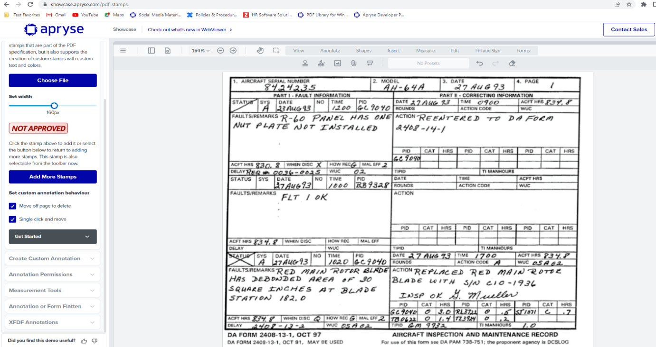

Annotation Support: Users can add, edit, and delete annotations using Apryse WebViewer's annotation tools. This includes creating text comments, highlighting text, drawing shapes, adding stamps, and more. Apryse WebViewer supports XFDF format for storing and managing annotations made on PDF documents.

**Granular Annotation Permissions***:* Apryse WebViewer enables airlines to set granular annotation permissions for different users or user groups.This level of control ensures that only authorised personnel can modify annotations, maintaining the integrity and accuracy of the annotation data captured in XFDF format.

**Real-Time Collaborative Annotation and Review:** Multiple users can access the same PDF document within Apryse WebViewer, add their annotations, and exchange comments. This facilitates efficient collaboration among team members, such as airline personnel, inspectors, or auditors, during the review process. XFDF data captures and preserves these annotations, ensuring synchronisation and consistency across users.

**Annotation Data Extraction:** Apryse WebViewer includes APIs and functionality for extracting annotation data, including XFDF data, from PDF documents. This allows airlines to programmatically retrieve annotation details for analysis, reporting, or integration with their document management or workflow systems. XFDF data extracted from Apryse WebViewer can be processed, archived, or used for further automation.

Ensuring Confidentiality with Redaction, as well as Transparency and Auditability in the Redaction Process

* **Compliance with Data Protection Regulations:**
  1. **Sensitivity of Passenger Info & Incident Reports:** Not protecting passenger privacy by redacting sensitive personal information from manifests would result in unauthorised access or misuse of personal data, potential privacy breaches, and non-compliance with data protection laws.
  2. **Sensitivity of Maintenance Records:** Not protecting proprietary information, trade secrets, or sensitive data in maintenance records by redacting relevant details risks intellectual property theft, compromise of trade secrets, unauthorised access to maintenance procedures, and non-compliance with regulations.
  3. **Sensitivity of Security Directives:** Not complying with security protocols by redacting sensitive information from security directives risks unauthorised access to critical information, compromise of national security, and non-compliance with security regulations.
* **Transparency,** **Auditability and Accurate Intent Communication:** Airlines need to demonstrate transparency in the redaction process by providing clear and justifiable reasons for redactions. The lack of redaction reasons can hinder transparency and make it difficult to audit redaction decisions. Document redaction often involves multiple stakeholders, such as legal teams, compliance officers, and data privacy officers. Each stakeholder may have distinct reasons for redaction based on their respective areas of expertise. Utilising multiple redaction reasons enables clear communication of intent, ensuring that the redaction aligns with organisational policies and objectives.
* **Efficient Revisiting of Original Information:** In scenarios where redacted information needs to be revisited, the absence of redaction reasons can make it challenging to locate the original unredacted content. With well-defined reasons, organisations can quickly identify and retrieve specific types of redacted information without compromising data security or accuracy.

Use Cases of Redaction in Airline Industry

Redacting Maintenance Reports with Granular Data Classification

In the airline industry, maintenance reports contain a wealth of information about aircraft maintenance activities, repairs, and inspections such as the following:

* **Proprietary Procedures and Techniques:** Proprietary maintenance procedures, repair techniques, or trade secrets unique to an airline or maintenance provider. Redaction of specific sections or details containing proprietary information to safeguard intellectual property and prevent unauthorised access.
* **Confidential Vendor Information:** External vendors or suppliers involved in maintenance activities. Redaction of sensitive vendor information, such as pricing terms, contract details, or proprietary business information, to maintain confidentiality and protect business relationships.
* **Aircraft Serial Numbers or Tail Numbers:** Specific aircraft by their serial numbers or tail numbers. Redaction of these identifiers to prevent the unauthorised identification of aircraft, maintaining security protocols and preventing potential misuse of sensitive information.
* **Personal Identifiers:** Names or employee identification numbers of maintenance personnel involved in inspections or repairs. Granular data classification allows for the redaction of these identifiers to protect the privacy and security of maintenance personnel.
* **Sensitive Aircraft Components:** Specific aircraft components, including their conditions, repairs, or replacements. Granular data classification enables the redaction of sensitive component details that could pose security risks or compromise proprietary information.

Redacting Security Directives to Protect National Security

Airlines receive security directives from regulatory bodies or government agencies that outline specific security measures or threat information. These directives may contain sensitive information related to national security, critical infrastructure, or emergency protocols. Redaction tools are employed to redact sensitive information and ensure compliance with security protocols and regulations.

In cases where airlines handle documents related to national security, adding a redaction reason such as "National Security - Protected Information" when redacting sensitive details demonstrates compliance with security protocols and safeguards critical information from unauthorised access.

The Apryse Solution for Redaction

* https://showcase.apryse.com/redaction

b   

Apryse WebViewer, combined with Optical Character Recognition (OCR) technology and the Apryse’s Intelligent Document Processing (IDP), can significantly increase productivity and streamline the process for identifying repair items within extensive maintenance histories for each asset.

**OCR Integration**: Apryse WebViewer can be integrated with OCR capabilities to extract text from scanned or unstructured documents within the extensive maintenance history. OCR technology converts images or scanned documents into machine-readable text, enabling the extraction of relevant information from repair logs, routine maintenance records, purchase orders, receipts, and other documents.

**Don’t “Dig for Data”:** Apryse IDP includes powerful PDF data extraction that recognizes and extracts any document layout along with content elements, such as tabular data and text, to structured JSON and Excel right out of the box. As a result, it gives organizations scalability and leading accuracy in PDF data extractions — it eliminates costs associated with extensive templating, rules, and data entry. By utilizing extracted text, users can perform targeted searches, significantly reducing the time and effort required to locate relevant documents among a large volume of records.

Resolving Manual Data Entry and Time-Intensive Search through Intelligent Document Processing

* **Manual Data Entry:** The traditional manual data entry process is time-consuming and prone to errors. By automating data extraction using OCR, the solution eliminates the need for manual data entry, saving significant time and reducing the risk of inaccuracies.
* **Tedious and Time-Intensive:** Manually searching through a large volume of documents to find specific repair items within extensive maintenance histories is a tedious and time-consuming task. The solution streamlines this process by enabling efficient search capabilities based on extracted OCR text, reducing the time and effort required to locate relevant repair logs.

Use Cases of Intelligent Document Processing (IDP) in Airline Industry

The aviation industry can integrate the Apryse IDP solution into its aircraft maintenance records management system to automate the extraction of critical data from PDF documents. By leveraging the powerful PDF data extraction capabilities of Apryse IDP, the industry gains the following benefits:

* Efficient Data Extraction: Apryse IDP accurately recognizes and extracts data from diverse document layouts found in maintenance records, such as part numbers, maintenance tasks, dates, technicians' names, and work descriptions. It efficiently processes large volumes of PDF documents, extracting structured JSON and Excel files with minimal human intervention.
* Organized Maintenance Records: The extracted data is automatically organized and structured, allowing for efficient management of maintenance records. Instead of manually sorting through numerous documents, maintenance personnel can access the extracted information in a structured format, ensuring easy retrieval and reference.
* Enhanced Search Capabilities: The structured data extracted by Apryse IDP enables users to perform targeted searches within the maintenance records database. Maintenance staff can quickly locate specific information, such as maintenance history for a particular aircraft component or compliance with specific service bulletins, reducing the time required for research and decision-making.
* Scalability and Cost Savings: Apryse IDP's out-of-the-box functionality eliminates the need for extensive templating and rule setup, allowing the aviation industry to scale its maintenance operations without incurring additional costs associated with data extraction. The solution streamlines the extraction process, reducing reliance on manual labor and accelerating overall productivity.
* Compliance and Audit Readiness: Accurate and well-organized maintenance records are crucial for regulatory compliance and audit readiness. By leveraging Apryse IDP's data extraction capabilities, the aviation industry ensures that maintenance records are complete, accurate, and easily accessible for audits and compliance inspections.

The Apryse Solution

* https://showcase.apryse.com/ocr-module

Apryse WebViewer, combined with Optical Character Recognition (OCR) technology and the Apryse’s Intelligent Document Processing (IDP), can significantly increase productivity and streamline the process for identifying repair items within extensive maintenance histories for each asset.

**OCR Integration**: Apryse WebViewer can be integrated with OCR capabilities to extract text from scanned or unstructured documents within the extensive maintenance history. OCR technology converts images or scanned documents into machine-readable text, enabling the extraction of relevant information from repair logs, routine maintenance records, purchase orders, receipts, and other documents.

**Don’t “Dig for Data”:** Apryse IDP includes powerful PDF data extraction that recognizes and extracts any document layout along with content elements, such as tabular data and text, to structured JSON and Excel right out of the box. As a result, it gives organizations scalability and leading accuracy in PDF data extractions — it eliminates costs associated with extensive templating, rules, and data entry. By utilizing extracted text, users can perform targeted searches, significantly reducing the time and effort required to locate relevant documents among a large volume of records.

Addressing the Need for Securing the PDF

* **Security Measures:** There are several challenges that the airline industry may face in ensuring the security of PDF documents such as unauthorized Access, Data Breaches, Document Sharing and Distribution.
* **Encryption:** To secure a PDF document with password protection and adjusting permissions on the document. Adding passwords to PDF documents in the airline industry helps safeguard sensitive information, control access, comply with data protection regulations, and maintain document integrity. It ensures that only authorized individuals can access and manipulate the documents, reducing the risk of data breaches or unauthorized modifications.
* **Watermark:** Technique commonly used in the airline industry to provide additional security, branding, and information on various documents. Here are some use cases of watermarking in the airline industry.

Use Cases to Protect PDF Documents in Airline Industry

* **Confidentiality of Sensitive information:** Airlines handle sensitive information such as passenger manifests, crew schedules, financial reports, and operational data. By adding passwords to PDF documents, the airline can restrict access to authorized personnel only, ensuring the confidentiality of the information and preventing unauthorized disclosure.
* **Secure Distribution of Sensitive Documents**: Airlines often share confidential documents with external stakeholders, such as partner airlines, regulatory bodies, or government agencies. Adding passwords to PDF documents before sharing them ensures that only intended recipients can access the files. This prevents unauthorized access or interception during transmission, enhancing data security.
* **Control Over Document Access and Permissions:** Password-protected PDF documents allow airlines to have control over who can open, view, edit, or print the documents. Different levels of password protection can be assigned, enabling the airline to manage access permissions based on the specific needs of each recipient or user.
* **Protection Against Unauthorized Modifications**: Password protection can prevent unauthorized modifications to PDF documents. For instance, if an airline distributes important policies, contracts, or regulatory compliance documents in PDF format, adding passwords can prevent unauthorized changes, ensuring the integrity of the information.
* **Confidential Documents:** Airlines often handle sensitive and confidential documents, such as financial reports, operational plans, or legal contracts. Watermarking these documents with phrases like "Confidential" or "For Internal Use Only" helps prevent unauthorized sharing or distribution. It serves as a visual reminder to handle the documents with care and reinforces the confidentiality obligations associated with them.

The Apryse Solution

* https://showcase.apryse.com/password-protect

**Password Protection:** You secure a PDF document with password protection and adjusting permissions on the document.

Watermark: Add watermark and update the text and easily place an overlay text on top of the original document.

Enabling Faster Search from Large Complex Documents

Searching within PDF documents in the airline industry can present certain challenges. Some of these challenges include:

**Large Document Sizes**: PDF documents in the airline industry, such as aircraft manuals, operational guides, or safety procedures, can be quite large and contain extensive amounts of information. Searching within these large documents can be time-consuming and resource-intensive, especially if the search functionality is not optimized for handling large file sizes.

**Complex Document Structures**: PDF documents in the airline industry often have complex structures with multiple sections, chapters, or subsections. Navigating through these structures and finding specific information can be challenging if the search functionality does not support advanced search options, such as searching within specific sections or subsections.

**Multilingual Content**: The airline industry operates globally, and PDF documents may contain multilingual content, such as flight manuals or regulatory documents in different languages. The search functionality needs to handle and process different languages accurately to ensure effective searching across diverse content.

Use Cases of Optimized PDF Search in Airline Industry

* **Aircraft Manuals:** Airlines maintain extensive aircraft manuals that contain detailed information on various systems, procedures, and troubleshooting guides. These manuals can be quite large and complex. The search functionality allows maintenance technicians and engineers to quickly search for specific keywords or phrases within the manuals, enabling them to find relevant information efficiently and accurately.
* **Regulatory Compliance:** The airline industry is subject to various regulatory requirements imposed by aviation authorities. Compliance manuals, regulatory documents, and guidelines can be stored in PDF format. The search functionality enables airline personnel to search for specific regulations, sections, or keywords within these documents. This simplifies the process of finding and referencing relevant regulatory information, ensuring compliance with applicable rules and regulations.
* **Safety Manuals and Procedures:** Safety is a critical aspect of the airline industry. Airlines maintain safety manuals, emergency procedures, and safety guidelines to ensure the well-being of passengers and crew members. With the search functionality, airline personnel can quickly search for specific safety procedures or guidelines during emergency situations or when conducting safety assessments and audits.
* **Crew Manuals and Training Materials:** Airlines provide extensive training to their flight crews, covering topics such as emergency procedures, operating manuals, and standard operating procedures (SOPs). These materials are often stored in PDF format. The search functionality allows crew members to search for specific procedures or information quickly, enhancing their ability to handle various scenarios and ensuring adherence to standardized protocols.

The Apryse Solution

* <https://showcase.apryse.com/pdf-search>

A screenshot of a computer

Description automatically gen   erated

Apryse provides several ways to search text content in a PDF document using wild card, regular expression, case sensitive, whole word:

* WebViewer UI built-in search
* WebViewer API
* PDFNet API

Enabling Seamless and High Performance Loading of Large Documents

* **Slow Document Loading:** PDF linearization addresses the pain point of slow document loading, especially for large PDF files. By structuring the PDF in a linearized format, essential parts of the document can be loaded progressively, allowing users to access the content quickly without waiting for the entire document to load. This significantly improves the user experience and eliminates the frustration of long loading times.
* **Limited Bandwidth:** In situations where bandwidth is limited, such as in-flight or in remote locations, PDF linearization becomes crucial. It enables efficient document loading and viewing even over low-bandwidth connections, ensuring that users can access the necessary information in a timely manner without experiencing significant delays or interruptions.
* **PDF “Fast Web View” or Linearization** is a way of optimising PDFs so they can be streamed into a client application in similar fashion to Youtube videos.
* This helps remote, online documents open almost instantly, without having to wait minutes or hours for a large document to completely download.
* Linearization is thus especially useful when accessing large documents from any remote URL or resource, be it from a browser, mobile, desktop or server application.
* Any airline industry working with large, network-bound documents should consider using linearization.

Use Cases of High Performance PDF Loading in Airline Industry

Refer to Airbus Aircraft characteristics and maintenance planning : <https://www.airbus.com/sites/g/files/jlcbta136/files/2021-11/Airbus-Commercial-Aircraft-AC-A320.pdf>

* Aircraft Maintenance Manuals: Airlines need to maintain comprehensive documentation for the maintenance and repair of their aircraft. These manuals can be extensive and include detailed procedures, diagrams, and specifications. By loading large PDF documents onto digital platforms, such as tablets or electronic flight bags (EFBs), maintenance technicians can access the relevant manuals quickly and efficiently. This eliminates the need for carrying and managing physical copies of the manuals, reducing the risk of loss or damage.
* Flight Operations Manuals: Airlines have operational manuals that provide guidance to pilots and flight crews. These manuals cover topics such as standard operating procedures, emergency procedures, performance charts, and navigational information. Loading large PDF documents onto EFBs allows pilots to have instant access to these manuals, enabling them to find critical information promptly. It also ensures that they have the most up-to-date versions of the manuals, as digital distribution allows for easy updates and version control.
* Safety Manuals and Procedures: Airlines prioritize safety and adhere to stringent safety protocols. Safety manuals, including emergency procedures, safety guidelines, and regulatory compliance documents, are essential for ensuring safe operations. Loading these large PDF documents onto digital platforms enables easy access and reference by crew members during critical situations. It facilitates rapid retrieval of information and promotes effective decision-making in emergency scenarios.
* Training Materials: The airline industry invests significantly in training programs for pilots, cabin crew, and maintenance personnel. Training materials often include comprehensive PDF documents with detailed instructions, procedures, and reference materials. By loading large PDF documents onto training systems and e-learning platforms, trainees can access the materials digitally, enhancing the learning experience.

The Apryse Solution

* <https://showcase.apryse.com/large-files>

A screenshot of a computer

Description automatically    generated with medium confidence

Digitizing and Automating Paper-based Manual Forms Filling

Paper-based forms in the airline industry can present several challenges. Here are some common challenges associated with paper-based forms:

**Manual Data Entry:** Paper forms require manual data entry, which can be time-consuming and prone to errors. Transcribing information from paper forms into digital systems increases the risk of data entry mistakes, leading to inaccuracies and delays in processing.

**Processing Delays:** Paper forms often require manual handling and routing through various departments or personnel for processing. This can result in delays, especially if there are bottlenecks in the workflow or if forms are misplaced or lost during the process.

**Data Security:** Paper forms are susceptible to unauthorized access and physical damage. Paper documents can be lost, stolen, or mishandled, potentially compromising sensitive information. Maintaining data security and ensuring compliance with data protection regulations can be challenging when dealing with paper-based forms.

Use Cases of Automated Form Filling in Airline Industry

* Passenger Forms: Airlines often require passengers to fill out various forms, such as passenger information forms, immigration forms, customs declarations, or special assistance requests. By providing fillable PDF forms, passengers can conveniently enter their information electronically, ensuring accuracy and legibility. Once the forms are completed, the airline can flatten the PDFs, creating non-editable versions for record-keeping or submission to relevant authorities.
* Maintenance and Repair Forms: Airlines need to document maintenance and repair activities for their aircraft and equipment. Fillable PDF forms can be used by maintenance technicians to record maintenance tasks, inspection results, parts replacement details, and work order information. Once completed, these forms can be flattened, ensuring that the recorded information remains intact and unalterable.
* Employment and HR Forms: Airlines have a range of HR-related forms that need to be filled out by employees or job applicants. These forms may include employment applications, background check authorizations, direct deposit forms, or benefits enrolment forms. By using fillable PDF forms, employees and applicants can complete these documents digitally, simplifying the process and reducing paperwork. Once submitted, the airline can flatten the PDFs to maintain consistent and unalterable records.

The Apryse Solution

* <https://showcase.apryse.com/pdf-forms>

A screenshot of a computer
  
Description automatic  ally generated

* Easily add form fields onto an existing PDF template - fields are first placed as an annotation and then converted to an interactive form field. Select from different types of form fields like text, signature, checkbox and more and easily create a PDF form document.
* You can access and fill any form field by its field id. Flatten the pdf document to remove interactivity.

Maintaining the Integrity of Confidential Documents

* Ensuring the confidentiality, integrity and authenticity of any document is a major challenge in any industry.
* Digital signature is primarily used to protect documents and is certified by certification authorities.
* A digital signature is a unique characteristic in digital form, something like a fingerprint embedded in a document. The signer must have a digital certificate to be associated with the document.
* The certification authority issues the digital signature. Digital signature is created using cryptographic algorithms.
* By leveraging digital signatures, the airline industry can improve security, streamline processes, enhance data integrity, and provide a more efficient and reliable experience for passengers, crew members, and other stakeholders.

Use Cases of Signatures in Airline Industry

* **Regulatory Compliance**: Airlines need to comply with various industry regulations and standards. Digital signatures can assist in signing compliance reports, safety documentation, and regulatory filings, providing a secure and traceable method for meeting legal requirements.
* **Maintenance and Engineering**: Digital signatures can play a crucial role in signing and validating maintenance and engineering documents, including maintenance logs, repair certificates, and technical manuals. This helps in ensuring the accuracy and authenticity of these critical records.
* **Certifications of training or qualifications.**
* **Flight/Dispatch release.**
* **Preflight Risk Analysis Worksheet.**
* **Maintenance logbook.**
* **Operational Control Briefing.**
* **Load Manifests.**

The Apryse Solution

* <https://showcase.apryse.com/digital-signatures>
* A screenshot of a co   mputer
    
  Description automatically generatezxcvzvzd
* Easily Sign PDFs with certificates using our JavaScript digital signature library and securely protect digital documents by creating a signing fingerprint uniquely identifying a sender.

Easily Manipulate the Page in PDF document

**Document Size and Performance:** Manipulating large PDF documents with many pages can impact performance and processing time. Operations such as inserting or extracting pages, especially in bulk, may require significant computational resources and time. Efficient handling of large documents is crucial to avoid delays and maintain productivity.

Page manipulation typically includes operations like Reorder, Insert, Merge, Split, Remove Pages, Crop Pages, Merge Documents.

Use Cases of Page Manipulation in Airline Industry

* **Document Assembly**: Airlines often need to compile multiple PDF documents into a single cohesive document. For instance, when preparing operational manuals, safety manuals, or regulatory compliance documents, various sections or chapters may be stored as separate PDF files. Page manipulation allows airline personnel to merge or rearrange pages from different PDF documents to create a consolidated and organized final document.
* **Report Generation**: Airlines generate various reports, such as financial reports, performance reports, or incident reports. Page manipulation enables the insertion of new pages, removal of unnecessary pages, or rearrangement of existing pages within the PDF document. This helps in creating concise and well-structured reports that present information in a logical and coherent manner.

The Apryse Solution

* <https://showcase.apryse.com/pdf-page-manipulation-api>
* A screenshot ofgsgsg a computer
  sdgsgsg
  Description automatisdgscally generated
* All page manipulation operations are performed securely in the memory of the browser without any server-side dependencies.
* Such operations can be done in browser and server side programmatically.

Architecture, Engineering & Construction

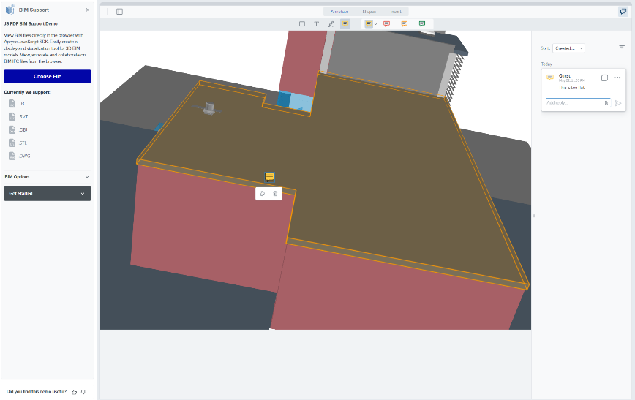

Pain Point:

* Architecture, engineering, and construction (AEC) professionals often face challenges when it comes to viewing and interacting with 3D files. Specialised software like AutoCAD, SolidWorks, and SketchUp are commonly used for this purpose, but they are not easily accessible to all business users.
* Additionally, providing feedback on specific areas of 3D models can be cumbersome.

With WebViewer, 3D files, including CAD and BIM files, can be easily viewed directly in a web browser. This eliminates the need for specialised software, making it accessible to a wider range of users within Indigo Airline and beyond.

Simplified Sharing and Review Process:

Engineers can easily share 3D assets with key decision makers and customers for review and comments. Instead of relying on heavy documentation or numerous images, stakeholders can directly access the 3D models through WebViewer. This streamlines the review process and enables a more efficient exchange of feedback.

Improved Collaboration between Airlines and Manufacturers:

Collaboration between airlines and manufacturers often involves sharing detailed information. By utilising 3D assets in WebViewer, specific details can be easily communicated, reducing the reliance on extensive documentation. Annotations and comments can be made directly on the 3D models, allowing for accurate and precise feedback. This enhances collaboration, facilitates better understanding, and ensures effective communication between the involved parties.

Office & Templating - Document Generation (Templating)

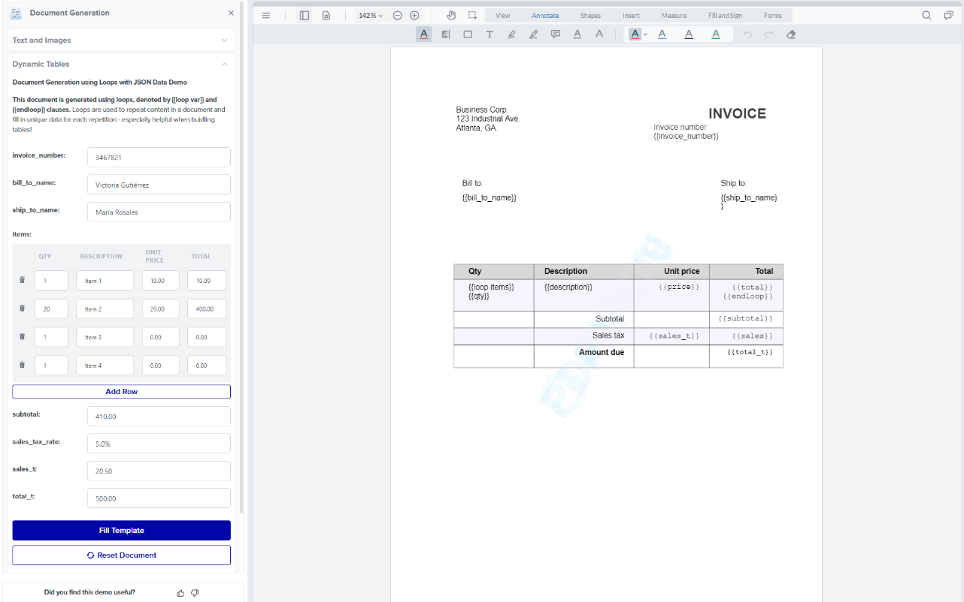

Pain Point:

* In office environments, generating large quantities of PDFs on the server can strain the infrastructure, particularly during high-volume operations.
* Additionally, generating dynamic PDFs for business processes can be complex, leading to potential errors in the information presented to end-users. Addressing these pain points is crucial to ensure efficient workflows and accurate document generation.

Apryse's Templating solution offers a comprehensive remedy for these challenges. By offloading CPU processing to end-users' browsers,

Templating allows for browser-based templating, where PDFs and data are retrieved separately. This approach minimises the burden on server infrastructure and simplifies the process of generating dynamic PDFs with accurate information for end-users.

Furthermore, Templating eliminates the need for constant URL updates or re-sending links when information needs to be updated.

Efficient and Scalable PDF Generation:

With Templating, mass generation of PDFs no longer strains the server infrastructure. By leveraging end-users' browsers for CPU processing, the load on the server is significantly reduced. This ensures smooth operations, even when generating PDFs in high quantities, resulting in improved performance and scalability.

Simplified Document Generation and Management:

Templating empowers business users to easily create new business processes with dynamic scheduling and documentation capabilities. Managers can effortlessly update schedules or modify the structure of documents without developer involvement. With a flexible templating system, changes can be made seamlessly, ensuring that staff and end-users always have access to up-to-date information through a single link.

Enhanced Marketing and Communication:

Sending brochures, promotional materials, and event information to end-users becomes effortless with Templating. By integrating with content management systems, such as those used by marketing or business development teams, relevant and visually appealing content can be designed and created. This allows for greater creativity and customization, enabling effective communication with end-users.

Office & Templating - Office Conversion

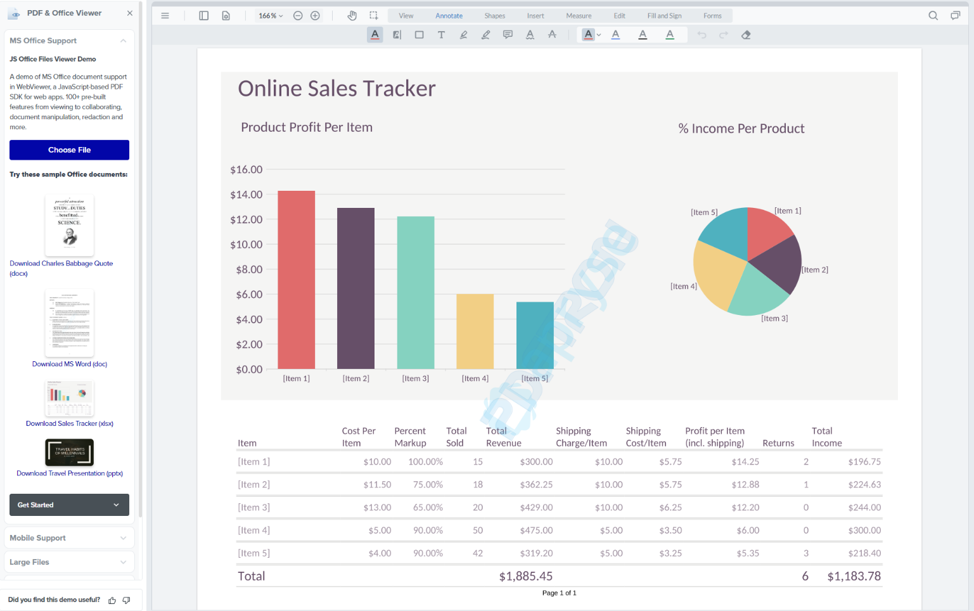

Pain Point:

* In administrative tasks, utilising the Office suite for content drafting and generation is common practice. However, there is often a need to convert these documents to PDF format when sending them to end-users.
* The conversion process typically relies on third-party dependencies, leading to slower conversion speeds and increased utilisation of cloud resources. To address these pain points, a streamlined and efficient Office conversion solution is necessary.

Apryse SDK can run in the browser and perform office conversion directly in the browser. Apryse SDK does not need a third-party dependency speeds up the conversion process and reduces consumption of cloud resources. Moreover, Apryse's proprietary Office conversion technology ensures reliable conversions and Apryse’s comprehensive support can address any encountered issues effectively.

Seamless Content Sharing:

With Apryse's Office Conversion, drafting marketing content and sharing it with other departments becomes hassle-free. Users can effortlessly convert Office documents to PDF format, ensuring compatibility and consistent document appearance across different platforms and devices. This simplifies content sharing and enhances collaboration between teams.

Efficient Presentation Slide Sharing:

Sharing presentation slides with staff becomes more streamlined with Apryse's Office Conversion. Users can convert PowerPoint presentations to PDF directly in the browser, ensuring that the content remains intact and accessible to all recipients, regardless of their device or software. This enables smooth and efficient communication within the organisation.

Effective Data Analytics Communication:

Key decision-makers often rely on Excel data points and graphs for informed decision-making. Apryse's Office Conversion facilitates the sharing of Excel data and graphs by converting them to PDF format. This ensures that the data is accurately presented and accessible to decision-makers, enabling better insights and analysis.

Media

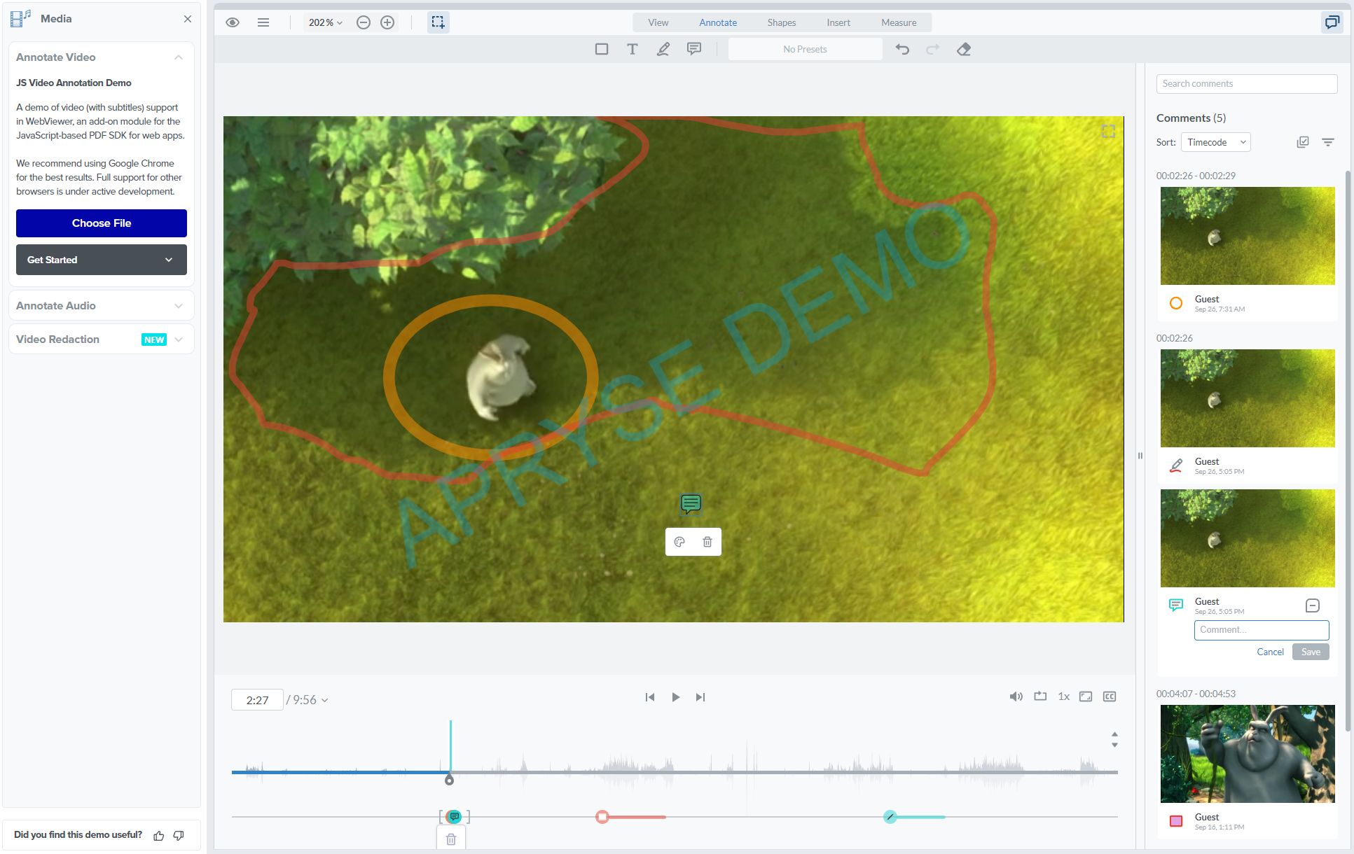

Pain Point:

* Sharing audio and video files is relatively easy. However, when it comes to gathering feedback and remarks on these files, friction can arise.
* Additionally, different types of files, such as documents and media files, are often shared through different links, requiring additional maintenance efforts. Addressing these pain points is crucial to streamline collaboration and enhance the sharing experience.

With WebViewer, media files can be shared directly within the WebViewer platform, eliminating the need for separate links or platforms for different file types. This simplifies the sharing process and reduces maintenance efforts.

Furthermore, WebViewer's annotation and redaction capabilities extend to media files, allowing for precise feedback and collaboration directly on the shared promotional videos or audios.

Seamless Sharing of Media Files:

WebViewer enables sharing of promotional videos or audios directly within WebViewer alongside other documents. This consolidates the sharing process, ensuring that all relevant files can be accessed through a single platform. Key decision-makers can easily access and review the media files, simplifying the feedback-gathering process.

Enhanced Collaboration and Feedback:

WebViewer's annotation and redaction features extend to media files, allowing stakeholders to provide precise feedback and remarks directly on the shared promotional videos or audios. This facilitates clearer communication, ensuring that opinions and suggestions are accurately conveyed. Collaborators can annotate specific areas of interest, making the feedback process more efficient and effective.

Compare

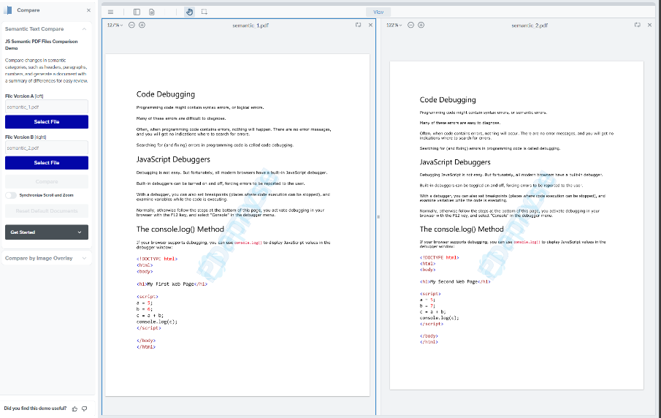

Pain Point:

* Dealing with large and complex PDFs, particularly when there are multiple versions of a document, can be a challenging task. Identifying the differences between these versions is crucial for effective collaboration and version control.
* Furthermore, comparing differences in design layouts can be a complex and time-consuming process.

With the ability to perform semantic comparison for text documents and overlay comparison for drawing documents, Apryse enables efficient and accurate document comparison. This streamlines the process of identifying changes, streamlines version control, and facilitates effective collaboration. Whether it's comparing changes in timeline documents received from partnering businesses or identifying differences in layouts like floor maps or building maps

Efficient Version Control:

Accelerates the processing of document contents and changes. Users can easily compare changes in documents, such as timelines received from partnering businesses. By identifying differences between versions, version control becomes more streamlined, ensuring that the most up-to-date information is readily available. This **enhances collaboration** and **decision-making processes**, saving time and effort.

Simplified Layout Comparison:

Comparing differences in layouts, such as floor maps or aircraft layout, becomes simpler. The overlay comparison feature enables users to identify changes in design versions quickly. This ensures that layout changes are accurately recognized, allowing for effective collaboration and efficient decision-making.

Accessibility

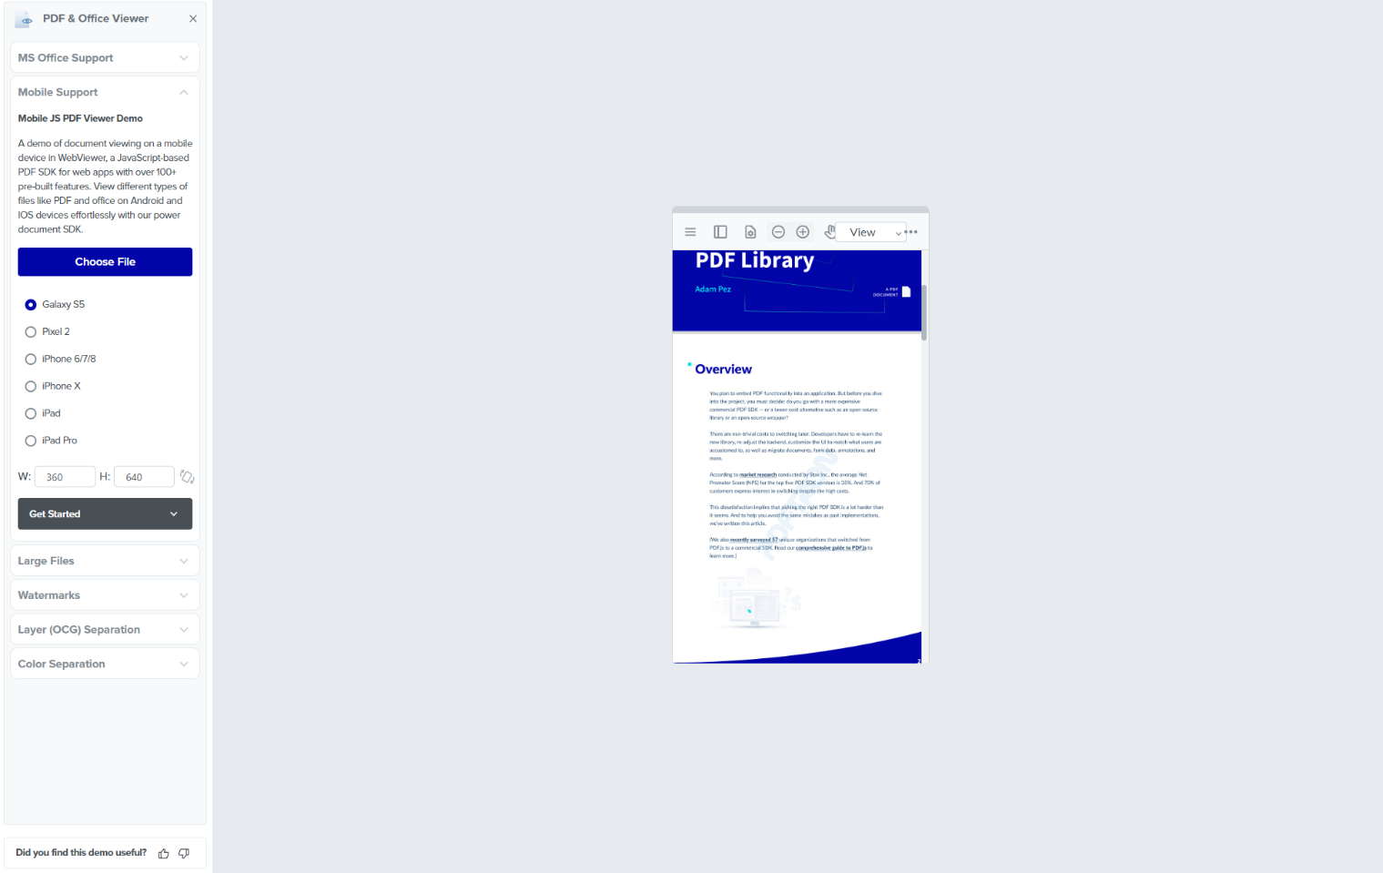

Pain Point:

* PDFs pose challenges due to their fixed formats and sizes, making it difficult to view large PDFs on smaller devices.
* Additionally, navigating through the contents of a document can be cumbersome, especially when dealing with lengthy documents.

With WebViewer's support for assistive technologies like screen readers, handicapped users can easily access and navigate through the content of PDFs.

The reflow feature in WebViewer allows for automatic adjustment of the number of words in a line based on the screen size, ensuring optimal readability on various devices.

Additionally, the ability to view and create a table of contents for the entire PDF streamlines document navigation and improves overall usability.

Enhanced Viewing Experience:

Whether reading from a computer or a mobile phone, users can expect a similar level of comfort and readability. This is particularly valuable when accessing content such as aircraft manuals or long checklists, where ease of use and accessibility are paramount.

Support for Assistive Technologies:

WebViewer's compatibility with assistive technologies like screen readers makes PDFs more accessible for handicapped users. By providing comprehensive support for screen readers, visually impaired users can navigate through the content of PDFs effectively, ensuring equal access to important information such as safety manuals or less important but useful information like onboard catalogues while on aircrafts.

Improved Document Navigation:

The table of contents feature in WebViewer enhances document navigation by providing a structured overview of the entire PDF. Users can easily jump to specific sections, chapters, or headings, making it quicker and more efficient to navigate through lengthy documents. This improves usability and saves time when searching for specific information.

PDF Editing

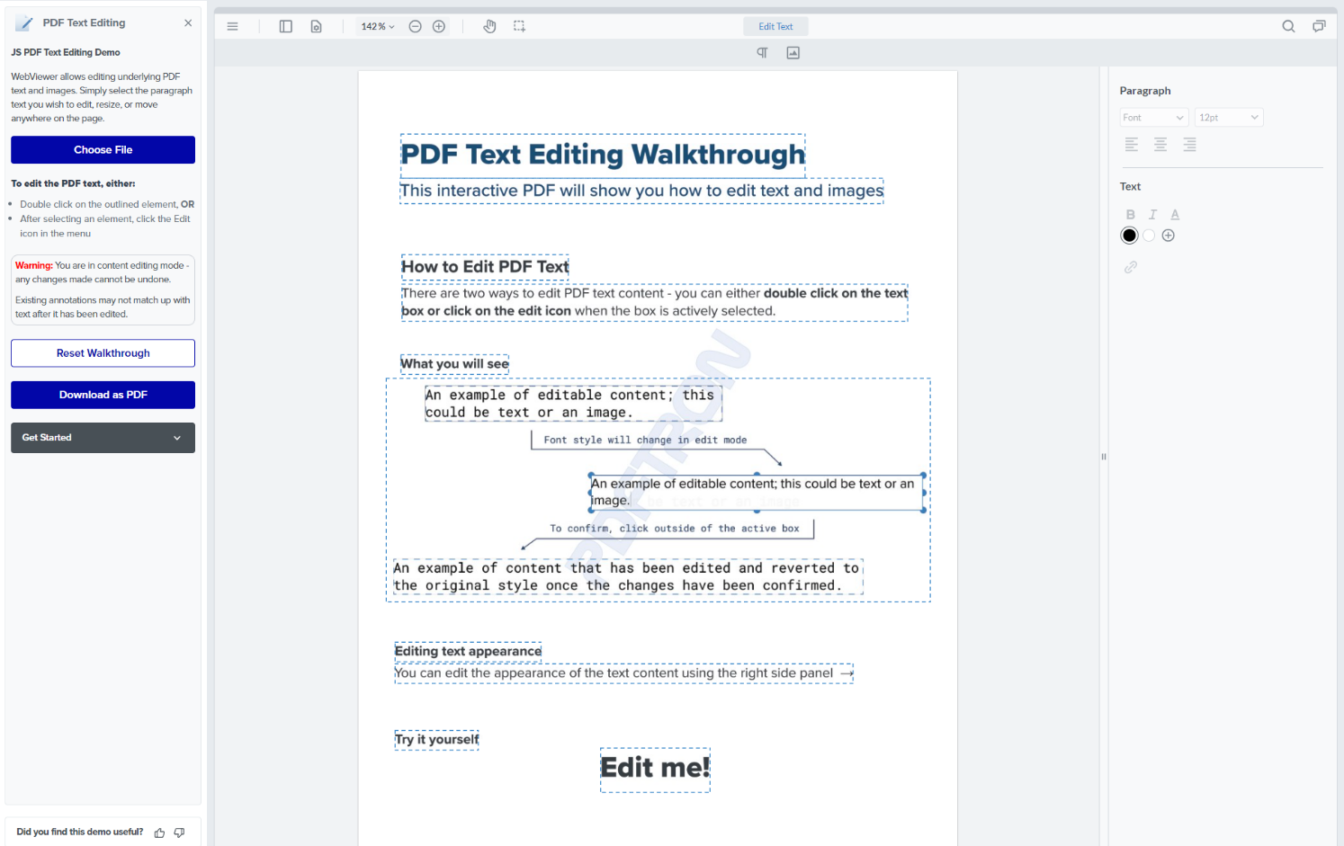

Pain Point:

* PDFs are inherently designed for static content and can pose challenges when users need to make edits without access to the source file. This becomes particularly problematic when users do not have the necessary software or licences to modify the source file that outputs the PDFs directly.

WebViewer provides a canvas-like editing experience for PDF text editing, akin to popular design tools like Figma and Miro.

Simplified Collaboration between Designers and Business Staff:

This eliminates the need for staff members to constantly rely on designers to make changes to the source files and generate output PDFs. Business staff can now directly edit the PDFs, making quick updates and modifications without requiring access to specialised design software. This streamlines the collaboration process, reduces bottlenecks, and promotes more efficient workflows.

Enhanced Collaboration between Airlines and Manufacturers:

In partnership or collaboration between businesses where document interchange predominantly occurs in PDF format, such as the airline and manufacturing sectors, making changes to documents can be a time-consuming process. Instead of waiting for variable response times from the sender, collaborators can make necessary changes themselves, expediting the collaboration process. Requests for changes are only required for significant modifications, resulting in a more streamlined and efficient workflow.